Default Schedule is 12:30am
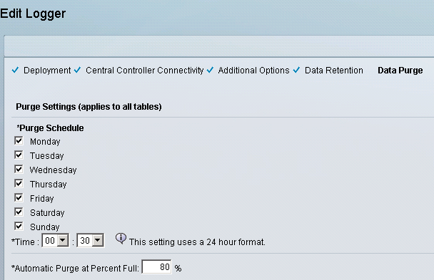
Clearly Cisco has provided ability to set it to anytime as shown below.
