Cisco COBRAS Export for Unity Connection Unrestricted
Issue:
Trying to backup Cisco Unity Connection 8.5 unrestricted version using COBRAS Export tool.
Information:
Unrestricted versions of Connection (those that lack high encryption capabilities) cannot allow message exports using IMAP via COBRAS because the super user IMAP access needed by COBRAS for this works only over TLS/SSL which is not supported on unrestricted versions. To get messages from an unrestricted version you need to use the /UseCUMI command line option which extracts messages via HTTP which is slower than IMAP but does not require the SSL support missing in unrestricted versions.
Starting with Unity Connection 8.5 and later you can use the “/UseCUMI” command line option to extract messages which allows messages to be pulled off the system using the REST based CUMI API instead of the IMAP API. This is necessary if you’re working with an “unrestricted” install of Unity Connection which does not allow for secure IMAP connections which are necessary for “super user” access to messages (secure IMAP is restricted by some countries).
To work the Unity Connection version must be 8.5 or later. “Super user” access to messages via CUMI was not in and fully supported until that version. If you’re at an unrestricted install prior to that version you will either have to leave voice messages out of the backup or first upgrade to 8.5 or later before migrating to a restricted installation of Unity Connection.
As a rule you only want to do this when absolutely necessary because CUMI is far slower and less efficient than traditional IMAP so you should only use this command line option if you’re pulling messages off an unrestricted installation of Unity Connection.
More information is available on following URL:
http://www.ciscounitytools.com/Applications/General/COBRAS/Help/COBRAS_Briefcase/COBRAS_Briefcase.htm#_Toc383446470
Procedure: How to use COBRAS Export to backup Cisco Unity Connection Unrestricted:
- Install COBRAS Export for Unity Connection
COBRAS Utility can be downloaded from the following link:
http://ciscounitytools.com/Applications/General/COBRAS/COBRAS.html
(Please refer the above link for full documentation and help)
Note: You need to Install “Informix ODBC Driver” in order to run COBRAS. Please install the correct Informix ODBC driver based on the Operating System you are running.
http://ciscounitytools.com/Applications/General/COBRAS/COBRAS.html

- Go to ‘Users’ page in Unity Connection Administration. Create a voicemail user. The account you use for attaching to Connection must be a user with a mailbox if you’re using the “/UseCUMI” command line option. The user must have both the remote access role (needed for ODBC) and the “Mailbox Access Delegate Account” role so they can gain access to all user mailboxes via CUMI during backup. This is checked prior to the export starting and you will get a warning message if that’s not configured properly and you’ve selected to include messages in the backup.
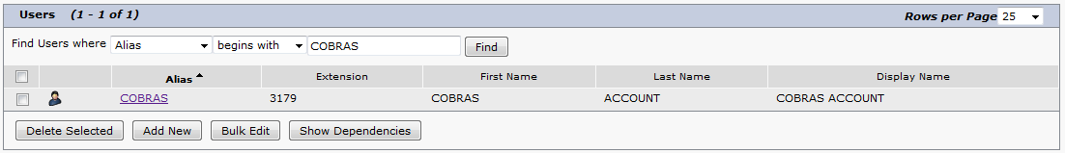
- Click on the ‘Edit’ menu of for the selected user and then click on “Password Settings”. Choose “Web Application” and Select “Do Not Expire”.
- Click on the ‘Edit’ menu of for the selected user and then click on ‘Change Password’. Choose “Web Application” and set the new password.
- Click on the ‘Edit’ menu of for the selected user and then click on ‘Roles’.
- Assign the roles “Remote Administrator” and “Mailbox Access Delegate Account” to the user and save the configuration.
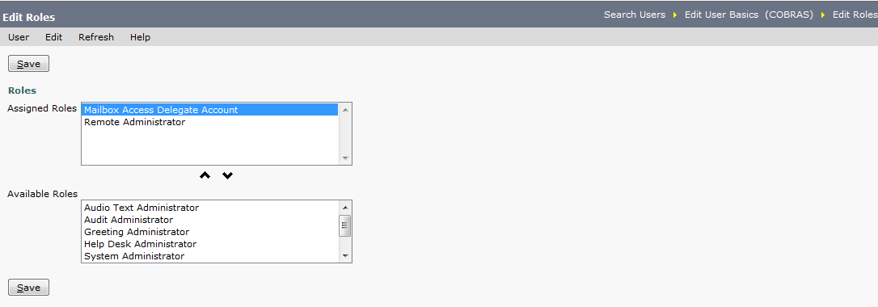
- Navigate to System Settings> Advanced> Connection Administration. Set the “Database Proxy: Service Shutdown Timer” to a non-zero value (e.g. 10 days).
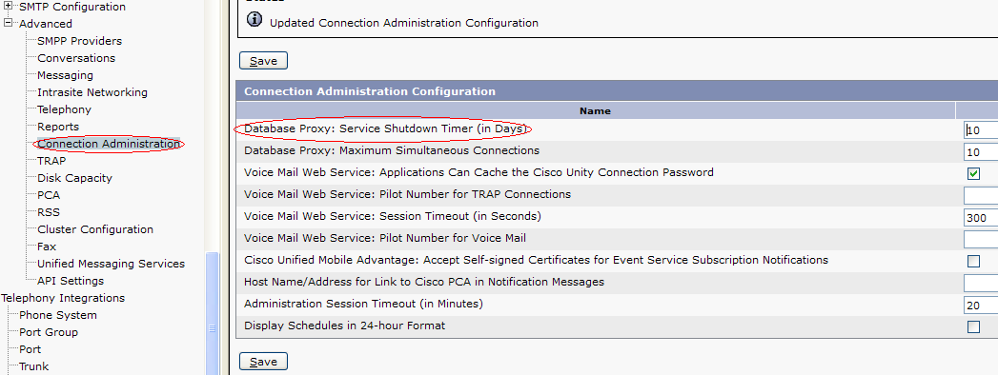
- Go to Cisco Unity Connection Serviceability Page.
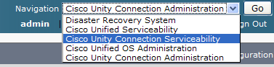
- Select “Service Management” from the ‘Tools’ Menu.
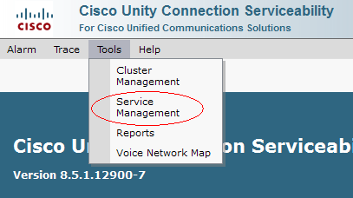
- Activate the Connection Database Proxy Service by clicking on the ‘Activate’ button. There is no need to activate this service on Unity Connection Subscriber server.
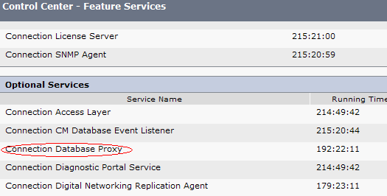
- Note down the directory where COBRAS Export for Unity Connection tool is installed. (e.g. C:\Program Files (x86)\Cisco Systems\COBRAS\COBRAS Export for Connection )
- Open Windows Command Line (CLI) program and go to the directory noted in the previous step.
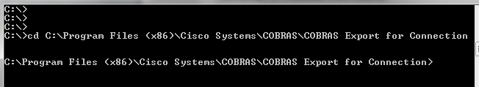
- Launch the COBRAS Export for Unity Connection using below command.
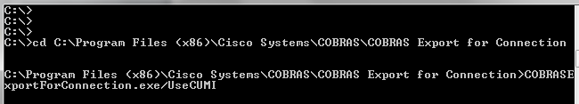
- Login the COBRAS utility using the credentials created in the earlier steps.
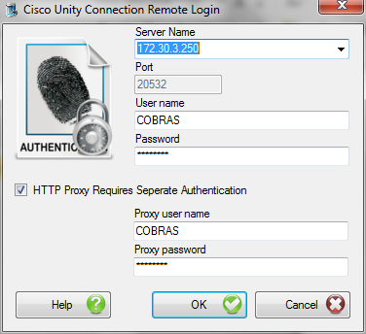
- Select Backup Options
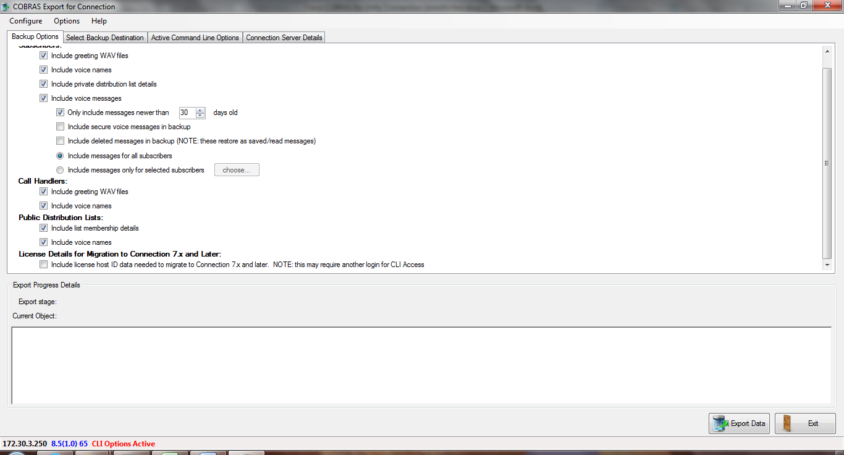
- Select Backup Destination
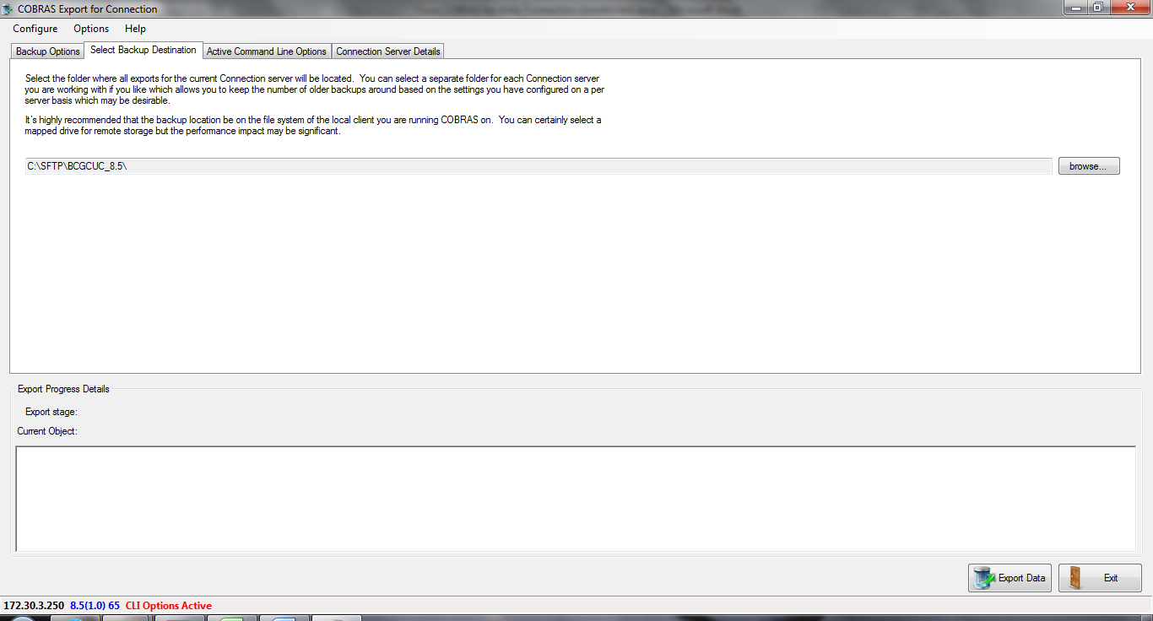
- You will see active command line options under “Active Command Line Options”.
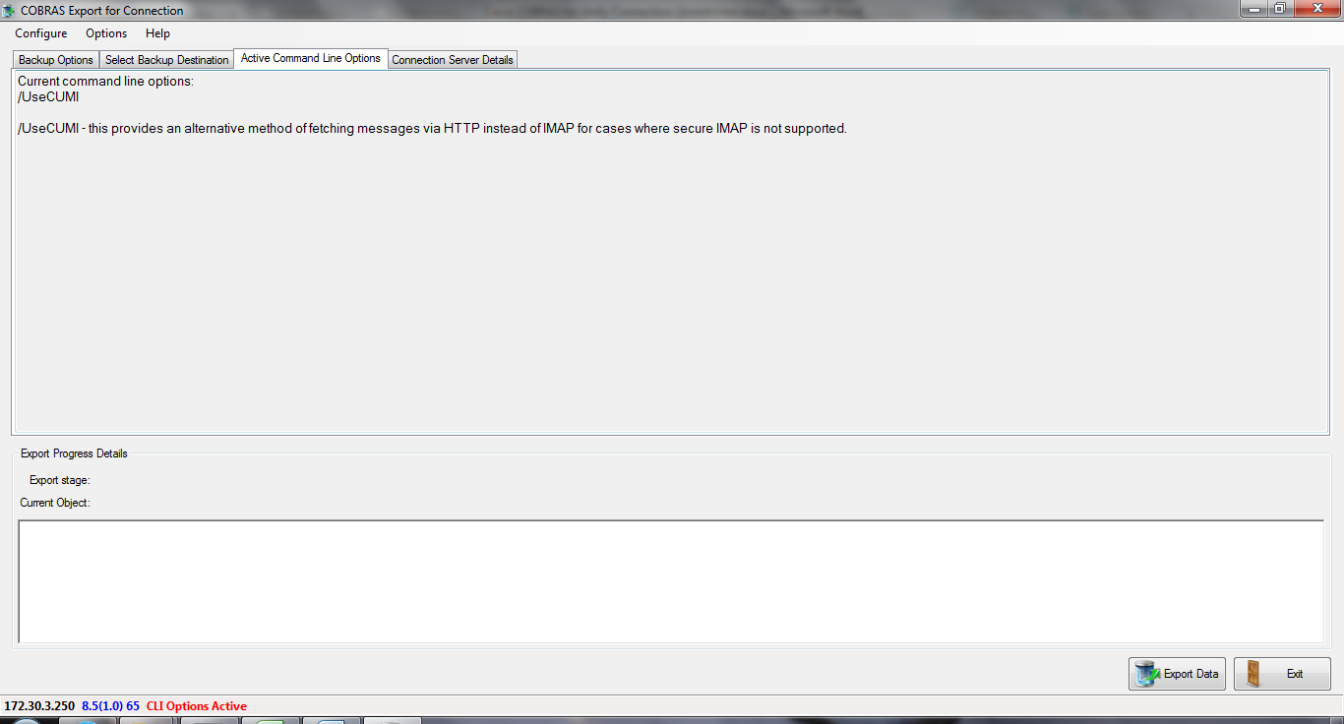
- Click Export Data. Sit back and relax…!

