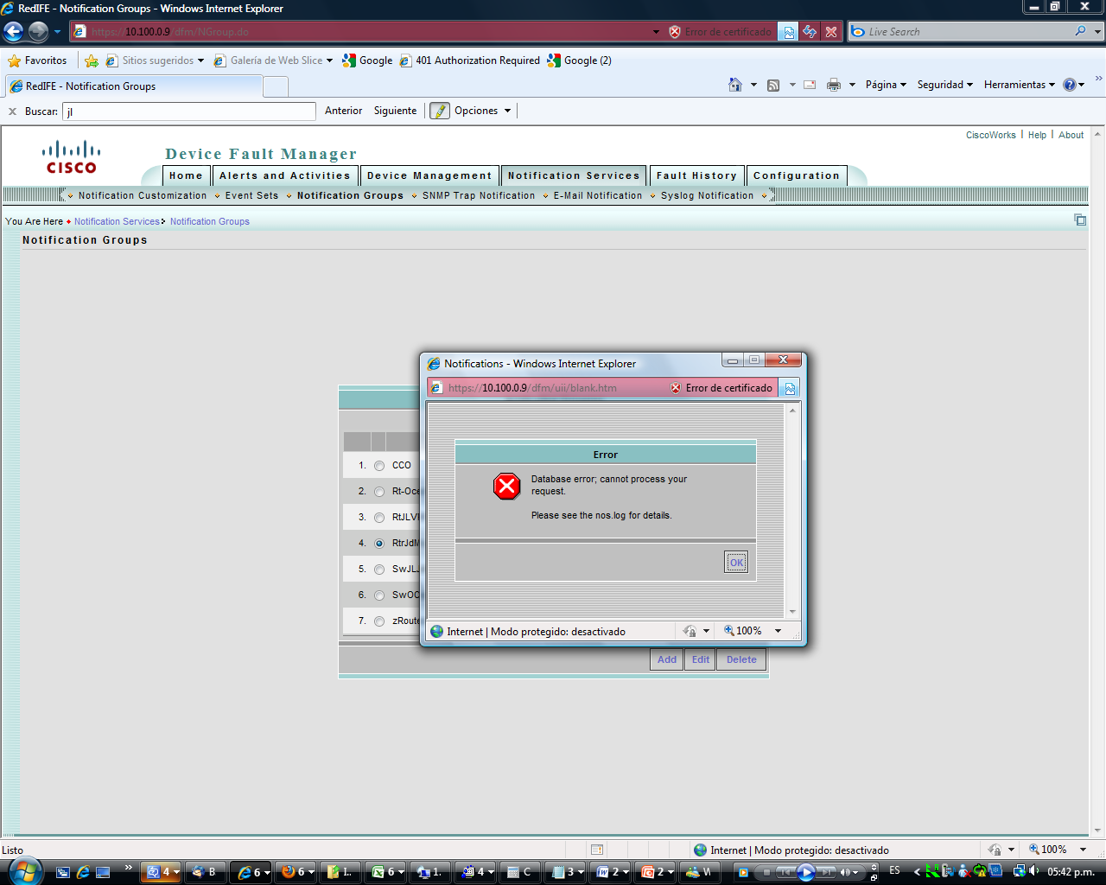

Pid = 15132
RC = 0
Signo = 0
Start = 10/29/2009 6:17:19 PM
Stop = Not applicable
Core = Not applicable
Info = ESS is fully up now !

Process= EventFramework
State = Program started - No mgt msgs received
Pid = 15492
RC = 0
Signo = 0
Start = 10/29/2009 6:17:25 PM
Stop = Not applicable
Core = Not applicable
Info = Server started by admin request

Process= PMServer
State = Running normally
Pid = 2384
RC = 0
Signo = 0
Start = 10/29/2009 6:17:25 PM
Stop = Not applicable
Core = Not applicable
Info = PMServer is up and running

Process= SyslogCollector
State = Program started - No mgt msgs received
Pid = 1692
RC = 0
Signo = 0
Start = 10/29/2009 6:17:29 PM
Stop = Not applicable
Core = Not applicable
Info = Server started by admin request

Process= EPMDbEngine
State = Program started - No mgt msgs received
Pid = 18320
RC = 0
Signo = 0
Start = 10/29/2009 6:17:32 PM
Stop = Not applicable
Core = Not applicable
Info = Application started by administrator request.

Process= EPMServer
State = Running normally
Pid = 13328
RC = 0
Signo = 0
Start = 10/29/2009 6:17:36 PM
Stop = Not applicable
Core = Not applicable
Info = EPMServer is up and running

Process= FHServer
State = Running normally
Pid = 5864
RC = 0
Signo = 0
Start = 10/29/2009 6:17:40 PM
Stop = Not applicable
Core = Not applicable
Info = FHServer started.

Process= diskWatcher
State = Running normally
Pid = 8200
RC = 0
Signo = 0
Start = 10/29/2009 6:17:40 PM
Stop = Not applicable
Core = Not applicable
Info = diskWatcher initialized OK.

Process= DFMMultiProcLogger
State = Program started - No mgt msgs received
Pid = 4400
RC = 0
Signo = 0
Start = 10/29/2009 6:17:41 PM
Stop = Not applicable
Core = Not applicable
Info = Server started by admin request

Process= DFMLogServer
State = Program started - No mgt msgs received
Pid = 17552
RC = 0
Signo = 0
Start = 10/29/2009 6:17:42 PM
Stop = Not applicable
Core = Not applicable
Info = Server started by admin request

Process= DFMCTMStartup
State = Administrator has shut down this server
Pid = 0
RC = 0
Signo = 0
Start = 10/29/2009 6:17:42 PM
Stop = 10/29/2009 6:20:13 PM
Core = Not applicable
Info = Server started by admin request

Process= DfmBroker
State = Program started - No mgt msgs received
Pid = 12268
RC = 0
Signo = 0
Start = 10/29/2009 6:17:42 PM
Stop = Not applicable
Core = Not applicable
Info = Server started by admin request

Process= DfmServer
State = Running normally
Pid = 14972
RC = 0
Signo = 0
Start = 10/29/2009 6:17:46 PM
Stop = Not applicable
Core = Not applicable
Info = DfmServer initialized OK.

Process= DfmServer1
State = Running normally
Pid = 8272
RC = 0
Signo = 0
Start = 10/29/2009 6:17:46 PM
Stop = Not applicable
Core = Not applicable
Info = DfmServer1 initialized OK.

Process= CSRegistryServer
State = Running normally
Pid = 6940
RC = 0
Signo = 0
Start = 10/29/2009 6:17:46 PM
Stop = Not applicable
Core = Not applicable
Info = CSRegistryServer is running in other process

Process= CSDiscovery
State = Never started
Pid = 0
RC = 0
Signo = 0
Start = N/A
Stop = Not applicable
Core = Not applicable
Info = Not applicable,

Process= CmfDbEngine
State = Program started - No mgt msgs received
Pid = 5932
RC = 0
Signo = 0
Start = 10/29/2009 6:17:50 PM
Stop = Not applicable
Core = Not applicable
Info = Application started by administrator request.

Process= CmfDbMonitor
State = Running normally
Pid = 4936
RC = 0
Signo = 0
Start = 10/29/2009 6:17:54 PM
Stop = Not applicable
Core = Not applicable
Info = DbMonitor Running Normally.

Process= DCRServer
State = Running normally
Pid = 3920
RC = 0
Signo = 0
Start = 10/29/2009 6:17:57 PM
Stop = Not applicable
Core = Not applicable
Info = DCRServer is up and running

Process= CMFOGSServer
State = Program started - No mgt msgs received
Pid = 15916
RC = 0
Signo = 0
Start = 10/29/2009 6:18:09 PM
Stop = Not applicable
Core = Not applicable
Info = Server started by admin request

Process= CampusOGSServer
State = Program started - No mgt msgs received
Pid = 4756
RC = 0
Signo = 0
Start = 10/29/2009 6:18:13 PM
Stop = Not applicable
Core = Not applicable
Info = Server started by admin request

Process= EssentialsDM
State = Running normally
Pid = 17236
RC = 0
Signo = 0
Start = 10/29/2009 6:18:13 PM
Stop = Not applicable
Core = Not applicable
Info = RME Device Management started.

Process= ConfigMgmtServer
State = Program started - No mgt msgs received
Pid = 12164
RC = 0
Signo = 0
Start = 10/29/2009 6:18:20 PM
Stop = Not applicable
Core = Not applicable
Info = Server started by admin request

Process= ICServer
State = Running normally
Pid = 18216
RC = 0
Signo = 0
Start = 10/29/2009 6:18:20 PM
Stop = Not applicable
Core = Not applicable
Info = ICServer started.

Process= RMEOGSServer
State = Program started - No mgt msgs received
Pid = 17044
RC = 0
Signo = 0
Start = 10/29/2009 6:18:20 PM
Stop = Not applicable
Core = Not applicable
Info = Server started by admin request

Process= TISServer
State = Program started - No mgt msgs received
Pid = 17256
RC = 0
Signo = 0
Start = 10/29/2009 6:18:21 PM
Stop = Not applicable
Core = Not applicable
Info = Server started by admin request

Process= DFMOGSServer
State = Program started - No mgt msgs received
Pid = 12860
RC = 0
Signo = 0
Start = 10/29/2009 6:18:25 PM
Stop = Not applicable
Core = Not applicable
Info = Server started by admin request

Process= InventoryCollector
State = Running normally
Pid = 13996
RC = 0
Signo = 0
Start = 10/29/2009 6:18:29 PM
Stop = Not applicable
Core = Not applicable
Info = InventoryCollector is up and running

Process= Interactor
State = Program started - No mgt msgs received
Pid = 12480
RC = 0
Signo = 0
Start = 10/29/2009 6:18:33 PM
Stop = Not applicable
Core = Not applicable
Info = Server started by admin request

Process= InventoryCollector1
State = Program started - No mgt msgs received
Pid = 2064
RC = 0
Signo = 0
Start = 10/29/2009 6:18:33 PM
Stop = Not applicable
Core = Not applicable
Info = Server started by admin request

Process= Interactor1
State = Program started - No mgt msgs received
Pid = 16648
RC = 0
Signo = 0
Start = 10/29/2009 6:18:37 PM
Stop = Not applicable
Core = Not applicable
Info = Server started by admin request

Process= NOSServer
State = Running normally
Pid = 6072
RC = 0
Signo = 0
Start = 10/29/2009 6:18:38 PM
Stop = Not applicable
Core = Not applicable
Info = NOSServer is up and running

Process= PTMServer
State = Running normally
Pid = 13812
RC = 0
Signo = 0
Start = 10/29/2009 6:18:38 PM
Stop = Not applicable
Core = Not applicable
Info = Started Successfully

Process= EDS-GCF
State = Running normally
Pid = 15684
RC = 0
Signo = 0
Start = 10/29/2009 6:18:39 PM
Stop = Not applicable
Core = Not applicable
Info = GCF Initialization complete at Thu Oct 29 18:19:52 CST 2009

Process= jrm
State = Running normally
Pid = 16084
RC = 0
Signo = 0
Start = 10/29/2009 6:18:39 PM
Stop = Not applicable
Core = Not applicable
Info = Server started by admin request

Process= CTMJrmServer
State = Running normally
Pid = 10888
RC = 0
Signo = 0
Start = 10/29/2009 6:19:37 PM
Stop = Not applicable
Core = Not applicable
Info = CTMJrmServer started.

Process= ChangeAudit
State = Program started - No mgt msgs received
Pid = 4924
RC = 0
Signo = 0
Start = 10/29/2009 6:19:48 PM
Stop = Not applicable
Core = Not applicable
Info = Server started by admin request

Process= SyslogAnalyzer
State = Program started - No mgt msgs received
Pid = 17764
RC = 0
Signo = 0
Start = 10/29/2009 6:19:49 PM
Stop = Not applicable
Core = Not applicable
Info = Server started by admin request

Process= DataPurge
State = Administrator has shut down this server
Pid = 0
RC = 0
Signo = 0
Start = 10/29/2009 6:19:51 PM
Stop = 10/29/2009 6:20:32 PM
Core = Not applicable
Info = DataPurge initialization completed at Thu Oct 29 18:20:32 CST 2009.

Process= IPMProcess
State = Program started - No mgt msgs received
Pid = 15956
RC = 0
Signo = 0
Start = 10/29/2009 6:19:51 PM
Stop = Not applicable
Core = Not applicable
Info = Server started by admin request

Process= IPMOGSServer
State = Program started - No mgt msgs received
Pid = 17112
RC = 0
Signo = 0
Start = 10/29/2009 6:19:55 PM
Stop = Not applicable
Core = Not applicable
Info = Server started by admin request

Process= ANIDbEngine
State = Program started - No mgt msgs received
Pid = 16488
RC = 0
Signo = 0
Start = 10/29/2009 6:20:02 PM
Stop = Not applicable
Core = Not applicable
Info = Application started by administrator request.

Process= ANIServer
State = Running with busy flag set
Pid = 14976
RC = 0
Signo = 0
Start = 10/29/2009 6:20:06 PM
Stop = Not applicable
Core = Not applicable
Info = ANIServer started.

Process= UTMajorAcquisition
State = Never started
Pid = 0
RC = 0
Signo = 0
Start = N/A
Stop = Not applicable
Core = Not applicable
Info = Not applicable,

Process= MACUHIC
State = Running normally
Pid = 14036
RC = 0
Signo = 0
Start = 10/29/2009 6:20:10 PM
Stop = Not applicable
Core = Not applicable
Info = Started.

Process= UTLITE
State = Running normally
Pid = 14812
RC = 0
Signo = 0
Start = 10/29/2009 6:20:10 PM
Stop = Not applicable
Core = Not applicable
Info = Started.

Process= UTManager
State = Running normally
Pid = 12640
RC = 0
Signo = 0
Start = 10/29/2009 6:20:10 PM
Stop = Not applicable
Core = Not applicable
Info = Started.

Process= WlseUHIC
State = Running normally
Pid = 14984
RC = 0
Signo = 0
Start = 10/29/2009 6:20:10 PM
Stop = Not applicable
Core = Not applicable
Info = Started.

Process= AdapterServer1
State = Program started - No mgt msgs received
Pid = 4528
RC = 0
Signo = 0
Start = 10/29/2009 6:20:10 PM
Stop = Not applicable
Core = Not applicable
Info = Server started by admin request

Process= AdapterServer
State = Program started - No mgt msgs received
Pid = 16916
RC = 0
Signo = 0
Start = 10/29/2009 6:20:12 PM
Stop = Not applicable
Core = Not applicable
Info = Server started by admin request

C:\Documents and Settings\Administrator>

