CUPC error:

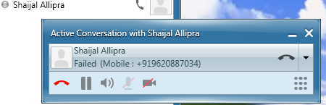
I created following application dial rules for the same but it didn’t work.

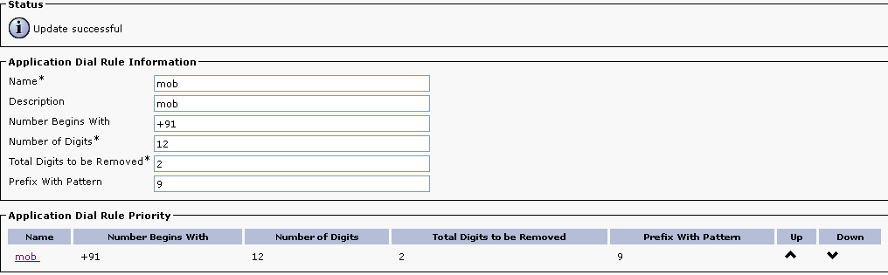
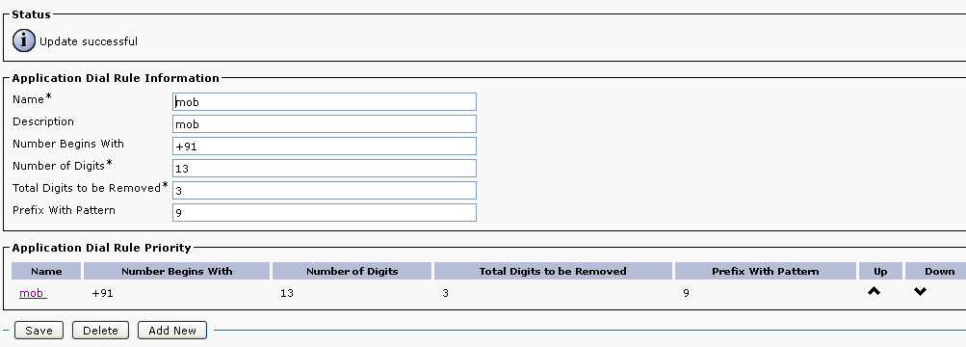

Route Pattern for mob calls
======================

